Sigma Chi
3.7
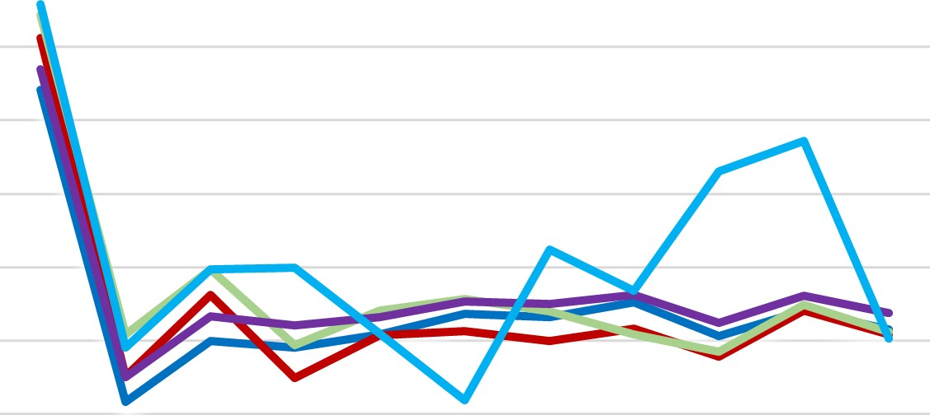
  All Male
  —All IFC
  All Greek All Student
  
3.6
3.5
3.4
3.3
3.2
3.1
3
2.9

S20 F 20 S21 F 21 S22 F 22 S23 F 23 S24 F 24 S25

